iBeaconSDK Description Document
- Import iBeaconSDK, add to library.
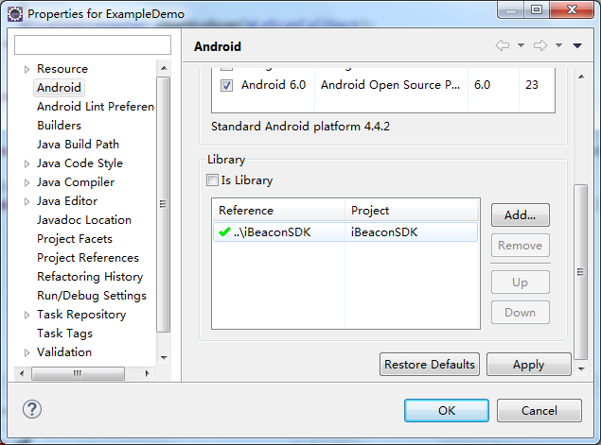
- Add permissions and services.
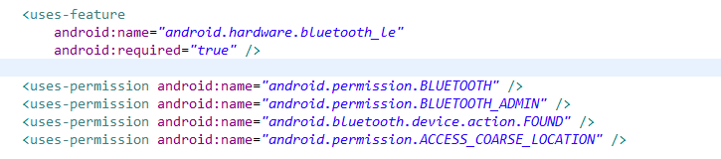
- To determine whether the device supports low-power Bluetooth, and request to open the Bluetooth.
if (!getPackageManager().hasSystemFeature(PackageManager.FEATURE_BLUETOOTH_LE)) {
Toast.makeText(this, "ble_not_supported", Toast.LENGTH_SHORT).show();
finish();
}
BluetoothManager bluetoothManager = (BluetoothManager) getSystemService(Context.BLUETOOTH_SERVICE);
mBluetoothAdapter = bluetoothManager.getAdapter();
if (mBluetoothAdapter != null && !mBluetoothAdapter.isEnabled()) {
mBluetoothAdapter.enable();
}
- Gets the Bluetooth processing object, which is used to process the data in the scan callback.
private iBeaconClass iBeaconClass;
iBeaconClass = com.axaet.ibeacon.beans.iBeaconClass.getInstance();
- In the scan callback, processing data, you can get the iBeacon object.
BluetoothAdapter.LeScanCallback mLeScanCallback = new BluetoothAdapter.LeScanCallback() {
@Override
public void onLeScan(final BluetoothDevice device, int rssi, byte[] scanRecord) {
if (device != null && rssi != 127) {
iBeacon beacon = iBeaconClass.formToiBeacon(device, rssi, scanRecord);
deviceAdpter.addData(beacon);
}
}
};
- Before modifying the parameters, we need to bind the service and register the broadcast.
registerReceiver(mGattUpdateReceiver, makeGattUpdateIntentFilter());
Intent gattServiceIntent = new Intent(this, BluetoothLeService.class);
bindService(gattServiceIntent, mServiceConnection, BIND_AUTO_CREATE);
/**
* broadcast action
*/
IntentFilter makeGattUpdateIntentFilter() {
final IntentFilter intentFilter = new IntentFilter();
intentFilter.addAction(BluetoothLeService.ACTION_GATT_CONNECTED);
intentFilter.addAction(BluetoothLeService.ACTION_GATT_DISCONNECTED);
intentFilter.addAction(BluetoothLeService.ACTION_DATA_ONGETUUID);
intentFilter.addAction(BluetoothLeService.ACTION_DATA_ONGETOTHER);
intentFilter.addAction(BluetoothLeService.ACTION_DATA_ONGETTH);
intentFilter.addAction(BluetoothLeService.ACTION_DATA_ONSEND);
intentFilter.addAction(BluetoothLeService.ACTION_PASSWORD_SUCCESS);
intentFilter.addAction(BluetoothLeService.ACTION_PASSWORD_ERROR);
return intentFilter;
}
ServiceConnection mServiceConnection = new ServiceConnection() {
@Override
public void onServiceConnected(ComponentName componentName, IBinder service) {
mBluetoothLeService = ((BluetoothLeService.LocalBinder) service).getService();
// After binding service, start the connection device
mBluetoothLeService.connect(address);
}

@Override
public void onServiceDisconnected(ComponentName componentName) {
mBluetoothLeService = null;
}
};

- After the connection is successful, we will receive a different action in the mGattUpdateReceiver.
BroadcastReceiver mGattUpdateReceiver = new BroadcastReceiver() {
@Override
public void onReceive(Context arg0, Intent intent) {
String action = intent.getAction();
if (BluetoothLeService.ACTION_GATT_CONNECTED.equals(action)) {
// Connect to a successful
} else if (BluetoothLeService.ACTION_GATT_DISCONNECTED.equals(action)) {
// Connection failed or disconnected
} else if (BluetoothLeService.ACTION_DATA_ONGETUUID.equals(action)) {
// After the connection, by enabling the notification to get to
// the UUID
textUuid.setText(intent.getStringExtra(BluetoothLeService.UUID_DATA));
} else if (BluetoothLeService.ACTION_DATA_ONGETOTHER.equals(action)) {
// After the connection, by enabling the notification to get to
// the majro,minor,period,txpower
}
// If your product does not have the temperature and humidity, it
// will not receive the broadcast.
else if (BluetoothLeService.ACTION_DATA_ONGETTH.equals(action)) {
intent.getIntExtra(BluetoothLeService.TEMPERATURE_DATA, -1);
intent.getIntExtra(BluetoothLeService.HUMIDITY_DATA, -1);
} else if (BluetoothLeService.ACTION_PASSWORD_SUCCESS.equals(action)) {
// Password correct, to modify the parameters
} else if (BluetoothLeService.ACTION_PASSWORD_ERROR.equals(action)) {
// Password error
Toast.makeText(ModifyBeaconActivity.this, "Password error", Toast.LENGTH_SHORT).show();
} else if (BluetoothLeService.ACTION_DATA_ONSEND.equals(action)) {
// Write data to the success of the callback, you can view which
// data is written to success
Log.i("yushu", Conversion.bytesToHexString(intent.getByteArrayExtra(BluetoothLeService.EXTRA_DATA)));
}
}
};
- Before modifying the parameters, we need to modify the data to determine whether or not to meet the requirements, where the value of txpower in 4, 0, -6, -23 in the choice of one.
if (TextUtils.isEmpty(password) || password.length() != 6) {
Toast.makeText(this, "Password length must be 6 characters",
Toast.LENGTH_SHORT).show();
return;
}
if (TextUtils.isEmpty(uuid) || uuid.length() != 32) {
Toast.makeText(this, "uuid length must be 32 characters",
Toast.LENGTH_SHORT).show();
return;
}

if (major > 65535 || major < 0) {
Toast.makeText(this, "0<=major<=65535", Toast.LENGTH_SHORT).show();
return;
}
if (minor > 65535 || minor < 0) {
Toast.makeText(this, "0<=minor<=65535", Toast.LENGTH_SHORT).show();
return;
}
if (period < 100 || period > 9800) {
Toast.makeText(this, "100<=minor<=9800", Toast.LENGTH_SHORT).show();
return;
}
- In before sending the data, we need to verify the password, after verification, we will in the mGattUpdateReceiver received action for BluetoothLeService.ACTION_PASSWORD_SUCCESS password success or BluetoothLeService.ACTION_PASSWORD_ERROR password error, Only when we receive the BluetoothLeService.ACTION_PASSWORD_SUCCESS, we can modify the data.
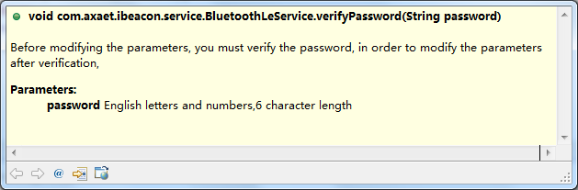
- After verifying the password, we can modify the data, each send a command, you need to delay for some time, and then send another command, the length of time is different, need to be tested, otherwise the change is not successful.
- modify UUID; method, parameter requirement as follows：
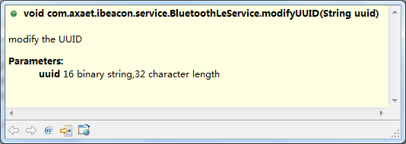
- modify the major,minor, period, txPower such parameters 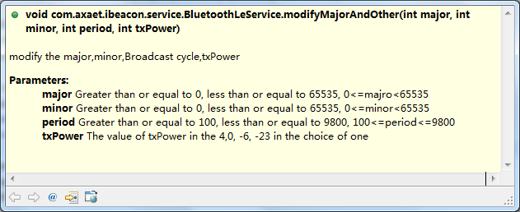
- modify the device name 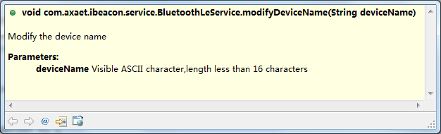
- modify the password：
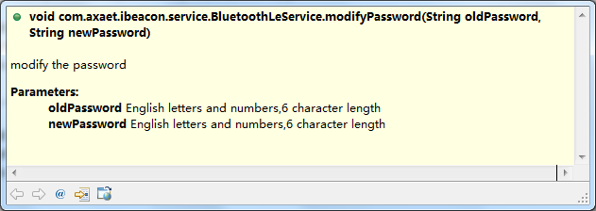
- After all the parameters have been modified, we need to close the device so that we can change our success..
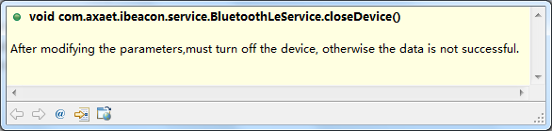
Reminder: if there is anything not clear, you can view our example

